Exercise 2: ARP and Switch operation

Topology
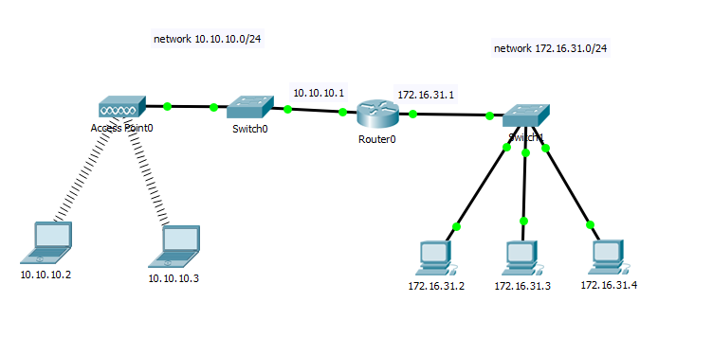

Addressing Table
Device | Interface | MAC address | Switch Interface
Router0 | G 0/0 | 00d0.97d4.9101 | G 0/1
 | G 0/1 | 00d0.97d4.9102 | G 0/1
10.10.10.2 | Wireless | 000A.F31D.497D | Fa 0/1
10.10.10.3 | Wireless | 00D0.BA82.6D78 | Fa 0/1
172.16.31.2 | Fa0 | 0002.4A41.BC5B | Fa 0/1
172.16.31.3 | Fa0 | 00E0.8F81.1CDA | Fa 0/2
172.16.31.4 | Fa0 | 0030.A327.9C18 | Fa 0/3

Open the packet tracer network “Exercise 2 - Packet Tracer - Examining ARP and Switch operation.pkt” provided on Canvas.

Examine the ARP process in a local network
- Open the command prompt of computer 172.16.31.2 and enter the command
    - C:\>arp –d
  - What does this command do?
- Enter the simulation mode and ping from 172.16.31.2 to 172.16.31.3. Two packets will be generated. The ping command cannot send the ICMP packet without knowing the MAC address of the destination. So the computer sends an ARP broadcast frame to find the MAC address of the destination IP address.
  - Is the source and destination MAC address present in the ICMP packet?
- Click Capture/Forward once. The ARP packet moves to Switch 1 while the ICMP packet disappears, waiting for the ARP reply with the MAC address of the computer with the destination IP address.
  - What is the destination MAC address of this ARP request?
  - What special kind of address is this MAC address?
  - What is the source MAC address of this ARP request?
- Click Capture/Forward once more to move the ARP request to the next device.
  - How many copiers of the ARP packet did Switch1 make?
  - Why?
  - What is the IP address of the device that accepted the ARP request?
  - What are the other devices doing with the ARP request?
- Click Capture/Forward one more time. The ARP reply is send to Switch1.
  - What are the source and destination MAC addresses of this ARP reply?
- Click Captrue/Forward until the ARP reply returns to 172.16.31.2.
  - How many copies of the ARP reply did the switch make?
  - Why?

- The ICMP packet reappears. Open the ICMP packet and examine the MAC address.
  - Do the MAC addresses of the source and destination align with their IP addresses?
- Switch packet tracer back to Realtime mode in order to complete the pings.
  - Where all the pings successful?
- Open a command prompt on 172.16.31.2 and enter the command
    - C:\>arp –a
  - What is the content of the ARP table?
- Examine the ARP table of 172.16.31.3 and 172.16.31.4. If all the ARP tables are empty, perform the ping command again. The entries in the APR table are removed after 5 minutes.
  - Are all the ARP tables the same on all computers?
  - Why (not)?
- Enter the simulation mode again and ping from 172.16.31.3 to 172.16.31.2. The ICMP packet is send to the destination without an ARP request.
  - Why does computer 172.16.31.3 not send an ARP request?

  - In general, when does an end device issue an ARP request?

Examine the ARP process when communicating to a remote network
- Open a command prompt on computer 172.16.31.2 and enter the command
    - C:\>ping 10.10.10.2
- Enter the command
    - C:\>arp –a
  - What is the ip address of the new ARP table entry?
  - Why?
- Open Router0 CLI and enter the following command to examine the routers ARP table:
  - Router#show arp
- Clear the ARP table on computer 172.16.31.2 and Router0
    - C:\>arp –d on 172.16.31.2
    - Router#clear arp on router
Router#reload
- switch to simulation mode.
- Repeat the ping to 10.10.10.2.
- Click Capture/Forward. Click the ARP request that is now at Switch1.
  - What is the destination IP address of the ARP request?
  - The destination IP address is not 10.10.10.1. Why?
- Click Capture/Forward one click at a time to examine the whole process. You should see the following sequence:
  - ARP request broadcast from 172.16.31.2 to the default gateway (router interface 172.16.31.1)
  - ARP reply from 172.16.31.1 router interface to 172.16.31.2.
  - ICMP request from 172.16.31.2 to 172.16.31.1 router interface
  - ARP request broadcast from 10.10.10.1 router interface to 10.10.10.2
  - ARP reply from 10.10.10.2 to 10.10.10.1 routers interface
  - First ICMP timed out
  - ICMP request from 172.16.31.2 to 172.16.31.1
  - ICMP request from 10.10.10.1 to 10.10.10.2
  - ICMP reply from 10.10.10.2 to 10.10.10.1
  - ICMP reply from 172.16.31.1 to 172.16.31.2
  - Second response is displayed in the command prompt of 172.16.31.2

Examine a Switch MAC Address Table
- Generate additional traffic to populate the switch MAC address table. Ping from 172.16.31.2 to 172.16.31.3, 172.16.31.4 and 10.10.10.2. Ping from 10.10.10.2 to 10.10.10.3.
- Click Switch1 and enter the following command to display the MAC address table:
    - Switch#show mac-address-table
  - Do the entries correspond to those in the table above?
- Click Switch0 and enter the following command to display the MAC address table:
    - Switch#show mac-address-table
  - Do the entries correspond to those in the table above?
  - Why are two MAC addresses associated with one port?

Examine switchport operation
- Ping from 172.16.31.2 to 172.16.31.3
- Open the Switch1 CLI and enter the following command to clear the MAC address table:
    - Switch#clear mac-address-table
- Enter simulation mode and ping from 172.16.31.2 to 172.16.31.3
  - Predict if the switch will either forward the ICMP packet to a specific port or flood the ICMP packet to all ports for the first Ping request. Why?
- Click Capture/Forward to see what happens with the packet at the switch.
- Examine the MAC address table of Switch1.
  - Why is this entry in the table?
- Click Capture/Forward until the first response arrives at computer 172.16.31.2.
  - Predict if the switch will either forward the ICMP packet to a specific port or flood the ICMP packet to all ports for the second Ping request. Why
- Click Capture/Forward to see what happens with the packet at the switch.
- Examine the MAC address table of Switch1.

